**20.2.1**

He is there

Thanks, Dieago

Do you want to talk to me?

Hello, Sofi

Eli

How are you my dear?

I'm well. How are you?

I'm well. I'm here for so much you great cooking. First, I want to talk with you

I have to been a kitchen to cook for customer

I'm the only customer here. Sit down. There is good restaurant to New York, but you make this restaurant great. Trust me, I know. I dinner restaurant a lot

Thank you, you're very kind

I want to know about you. **Where are you from, Sofi?**

**I’m from France**

Oh, you're French, A lot of good food form France

**Where are you from?**

**I'm from New York city**

**Where is your family from?** New York city?

No, **my family was from Germany**

**How old are you?**

**I'm 69 years old**

You don't look 69 years old

How old do I look?

Not a date over 50

Thank you. How old are you?

I'm 31 years old

That's a good age

Are you married?

Yes.

**Where is your wife?**

**She was not with us anymore**

Oh no, I'm sorry

It's OK. We were marry 50 years. I miss her

Who is Eli?

-> A regular customer

What does Eli want to do first?

-> Talk to Sofi

What does Eli tell Sofi?

-> He thinks she’s a really good cook

What do Eli and Sofi talk about?

-> How old they are and where they’re from

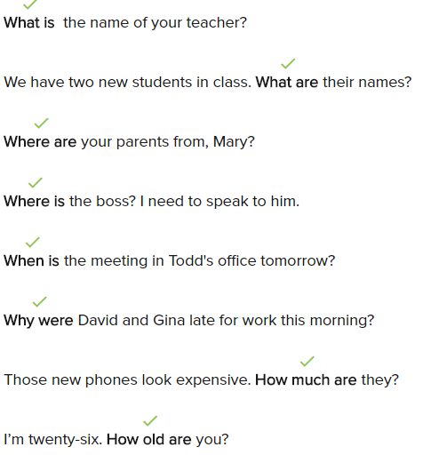

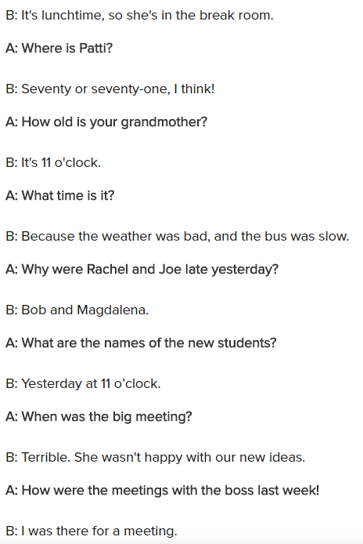

**Conversation**

Welcome back, How was the business trip last week?

Hi, Brittany! It was great, but now I’ve lot of question for you

Sure, ask me anything, what can I tell you?

First, I hear we have two new employees. What are the names?

Oh, You’re talking about a new product designer. The man is Manuel , and the woman is Alicia

Manuel and Alicia, thanks. And where are they from?

Manuel was a product designer with Company Company in Mexico, and Alicia was a computer engineer at Computer wold in London

These are good companies! Now tell me about a meting with the boss last Thursday was it?

It’s was terrible. The boss wasn’t happy with our idea for the new product

Uh oh, where is the next meting?

**Exercise**

Where are you from?

It’s my little brother’s birthday today!

-> That’s nice! How old is he?

Where is Rachel?

-> I think she’s in the break room

Sorry, I’m late

-> Where were you?

Where are Gisela and Pablo from?

-> She’s German, and he’s from Spain

Who are they?

-> They’re computer engineers

Why isn’t the boss happy with you?

-> Because I was late this morning

Welcome back! How was your trip?

-> It was great!

When is at the meeting?

-> Next Thursday

20.2.2

Are you married?

No, I’m single

**How many kids do you have?**

**I don’t have any children**

I don’t have any children

When do you want to have children?

I don’t know, after I get married

That’s a good time to get children. **When do you visit France and your**

**parents?**

**I don’t visit France**

**Why don’t you visit France ?**

**My parent aren’t with us anymore**

Oh. I’m sorry

It’s OK

I don’t miss France, I like New York

**Why do you live in New York?**

**I like the city**, it’s fun. There are a lot of things to do. I like to museums

Oh, you do? **When do you go to museums?**

**I like to go to museums on the weekend**

I like to go to museums on the weekdays

**Why do you go on weekdays?**

**There aren’t many people in museums on weekdays**. There are a lot of people there on weekend

That’s smart! I want to make lunch for you, **when do you want to eat?**

**Now is good**

OK, what can I make for you today?

I don’t know

How hungry are you?

I’m very hungry

OK, I can make you something great

Thank you Sofi

What does Sofi want to do after she is married?

-> She wants to have children

Sofi says she like New York City

Eli and Sofi say they like to visit museums

Eli like to go to museum on weekdays because there are’s lot of people on the weekdays

At the end, what does Sofi want to do?

-> cook something special for Eli

Franco, when do you watch sports on TV?

Anna, why do you go to museums on the weekends?

Juan, where do yo like to go on Saturdays?

Chen, how many times per week does your roommate order food for delivery?

Leila, why don’t you study English anymore?

Dimitri, what do you like doing in the evenings?

Elena, when does your mother serve dinner?

Basil, how do you get to work in the morning?

Skills Practice

I like it there because I can walk to work and there’s a lot to do

-> Why do you live downtown?

Is Saturday morning OK?

-> When do yo want to go shopping with me?

She’s a cook at a German restaurant on Tenth Street

-> Where does Gisala work now?

They meet at the gym on Wednesday evenings from 7:00 to 9:00

-> When do your brother and his friends play basketball

Because my classmates think I don’t have talent

-> Why don’t you want to go to acting class tonight?

He loves it!

-> How does John like his new job?

Next week, and she’s really excited about it

-> When does Rosita go to Mexico?

He works late a lot, so he doesn’t have time to study

-> Why doesn’t Fong take English lesson anymore?